December 22, 2021
California Citizens Redistricting Commission
C/O Public Comment
721 Capitol Mall, Suite 260
Sacramento, CA 95814

Re: Town of Danville Comments regarding Proposed Final Maps for Congressional, State Senate, and State Assembly
Dear Commissioners,
On behalf of the Town of Danville, I am writing in response to the proposed Final Maps for the Congressional, State Senate, and State Assembly Districts. The Town of Danville has expressed to this Commission through the Tri-Valley Cities Coalition the desire to keep our Tri-Valley Cities of Dublin, Livermore, Pleasanton, San Ramon, and the Town of Danville together as a Community of Interest (COI). We have sent three letters over the course of the process advocating for this and providing information as to the importance that we remain in one district.

Today I am writing to express again the Town of Danville’s desire for keeping the Tri-Valley Cities together for the Congressional, State Senate, and State Assembly Districts. The Tri-Valley has flourished over the years due to our tremendous cooperation, and our region is poised for even greater excellence moving forward. However, to continue to thrive and achieve our mutual goals, we must be able to work together in close collaboration with legislators dedicated to the needs of the Tri-Valley.

Additionally, I am writing to ask requesting a change to the State Assembly Map in which the Tri-Valley Cities would be split into two Districts (20 and 16). Splitting our Tri-Valley Cities apart is not in the best interest of our residents and does not ensure effective and fair representation.

I recognize that the Citizens Redistricting Commission has a unique and challenging responsibility but believe that the Town must remain together in one District for the State Assembly and that the Tri-Valley Cities should remain in one district for the Congressional, State Senate and State Assembly Districts. It is imperative we be included within a single district and not divided for purposes of effective and fair representation.
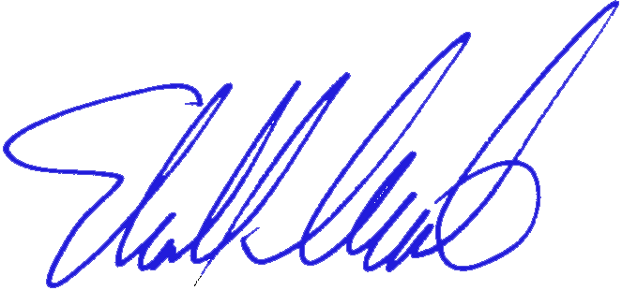
Sincerely,

_____________________________
NEWELL ARNERICH, MAYOR

cc: The Honorable Steven Glazer, George.Escutia@sen.ga.gov
The Honorable Rebecca Bauer-Kahan, John.Skoglund@asm.ca.gov

