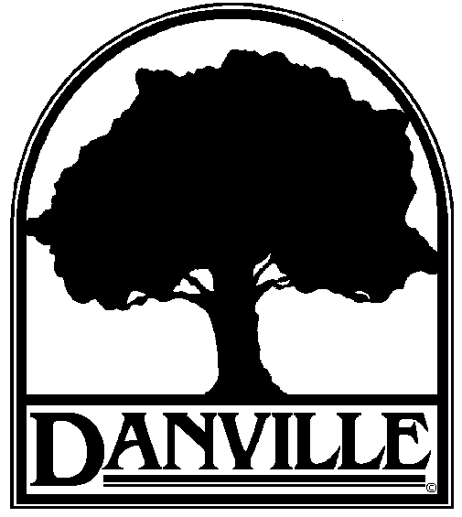 | TOWN OF DANVILLE  510 La Gonda Way  Danville, CA 94526  Phone (925) 314-3388  Fax (925) 838-0548  http://www.danville.ca.gov/
Press Release
Contact: Christian Mejia  Phone: (925) 314-3418 | FOR IMMEDIATE RELEASE  10:30 a.m. June 7 , 2018

Music in the Park Returns
Summer concert series in Danville parks

Danville’s much loved outdoor concert series Music in the Park is back for its 33rd year. Fans of live music can expect a variety of exciting and energetic bands to entertain over several Saturdays this summer. Come out and join us for some fun in the sun!

June 23 at Oak Hill Park
The Big Jangle
Capturing the Tom Petty and the Heartbreakers concert experience, The Big Jangle not only plays the music of Tom Petty, but the songs he covered live such as The Traveling Wilburys, The Byrds, and Stevie Nicks.

July 7 at Oak Hill Park
Stealin’ Chicago
This band is dedicated to a faithful re-creation of the music recorded by Terry Kath, Robert Lamm, and Peter Cetera. The unique sound incorporates a strong use of melodic horn lines and THE sound of Chicago.

July 21 at Oak Hill Park
A Touch of Class
This well-established R&B, Funk, Oldies, and Standards band features combined vocal harmonies, a heavy horn section, and choreography to create a high energy show.

August 11 at The Town Green
The Fog City Swampers
Whether you’re a “Mississippi Queen” or a “Simple Man,” this Classic Rock band will serve up a generous helping of rock and roll goodness. Expect to hear classics by artists like Lynyrd Skynyrd, CCR, Led Zeppelin, The Rolling Stones, Johnny Cash, and more.

All concerts are free and will be performed from 6 p.m to 8 p.m. Concerts at Oak Hill Park will include a selection of food trucks provided by Food Truck Mafia.

For more information visit www.danville.ca.gov/calendar or call (925) 314-3400.

